The Indian Navy's Evolving Order of Battle
Mr. Adithya Krishna Menon

Byline:
Amidst global tensions and delayed procurement and delivery of equipment, self-reliance is a key objective. With an eye on global advancements, the Navy is looking to accelerate the induction of uncrewed systems.
The Indian Navy is one of the providers of net security in the Indian Ocean Region. The maritime expanse spans from the Bab Al-Mandeb Strait in the west to the Strait of Malacca in the east, while to the south it extends as far as Antarctica, with a few island nations and territories en route. The Indian Navy is a blue water force with regular global operational deployments to safeguard and represent India's interests. Its organisational structure is split between three commands. The Eastern command has operational responsibility for the Bay of Bengal, Andaman Sea (in conjunction with the tri-service Andaman and Nicobar Command), and all force projections to the east. The Western Command patrols the Arabian Sea, Persian Gulf, Mozambique channel, Red Sea, and long-range deployments west of the Suez Canal. The Southern Command is primarily a training command with routine regional deployments to friendly foreign nations.
The numerical strength of the Indian Navy’s arsenal has been increasing, although the pace of inductions remains below earlier projections. The flagships of the fleets are the two Short Take-Off But Arrested Recovery (STOBAR) aircraft carriers, Indian Naval Ship (INS) Vikramaditya and INS Vikrant. Both motherships are supported by destroyers under the Project 15 family. The newest destroyers are four P-15B Visakhapatnam class destroyers, which were preceded by three P-15A Kolkata class destroyers. Both are equipped with BrahMos supersonic cruise missiles and medium-range surface-to-air missiles (MRSAM). The original P-15 Delhi class continues to be in service in a heavily upgraded avatar, now armed with new radars and BrahMos missiles. Three of the Soviet-era Rajput-class destroyers round up the destroyer strength. Notably, the Rajput class continues to serve as a testbed for major new equipment. INS Rajput was the first ship to fire the BrahMos from an inclined launcher, while INS Ranvir was the first to fire BrahMos from a Vertical Launch System (VLS). INS Rana is currently used to test the Vertical Launch Short Range Surface-to-Air Missile (VLSRSAM) as well as the associated Multi-Function Radar (MFR). Projects like the Next Generation Destroyer are expected to gather pace in the coming years and will likely be significantly larger than existing classes.

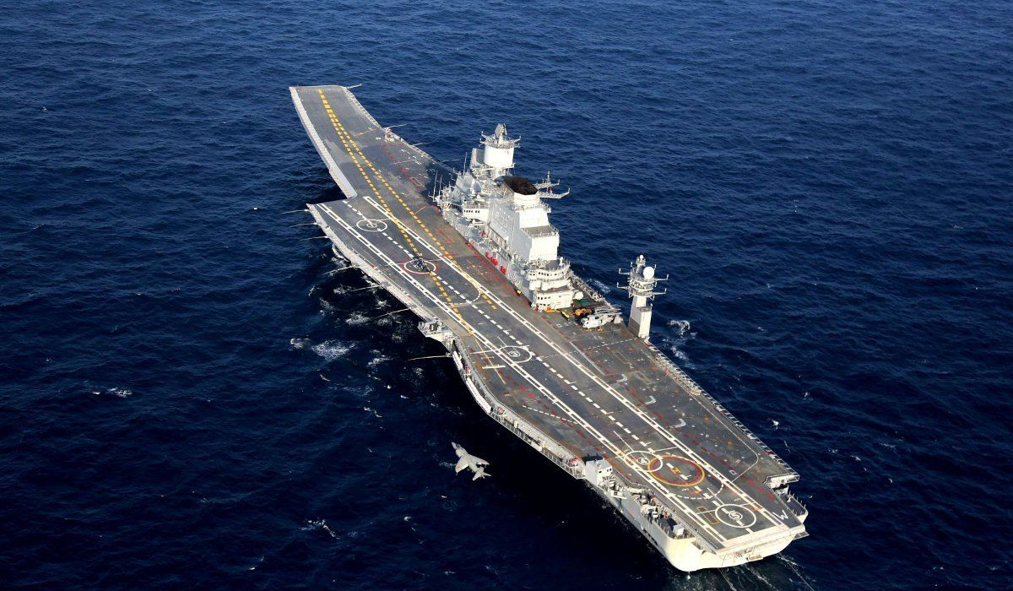INS Vikramaditya (R33) with a Sea Harrier aircraft in the Arabian Sea
Source : wikimedia.org
The Navy’s frigates form the backbone of routine frontline operations and are deployed around the world for various operations, exercises, and diplomacy. The indigenous Nilgiri class and its predecessor, the Shivalik class, are among the most modern frigates of the Navy. Four of the seven Nilgiri class vessels have been commissioned, while three Shivalik class vessels have the unique distinction of having both the Sthil-1 arm-launched SAM and the Barak-1 SAM. The Russian-origin Talwar class consists of eight ships, which have been inducted in batches over decades. The last two ships of this class are being constructed in India by Goa Shipyard Limited. The venerable Brahmaputra class is the oldest and smallest frigate in Indian service. The Next Generation Corvette program will result in eight vessels, which are comparable to the Talwar class in size and armament rather than the existing corvettes.

Multiple classes of corvettes are being utilised for various roles by the Navy. The Anti-Submarine Warfare Shallow Water Craft (ASW-SWC) program includes sixteen vessels, eight each built by GRSE and Cochin Shipyard Limited. Four of these vessels are in service. The ASW-SWC is substantially smaller than the four Kamorta class corvettes, which are also dedicated to ASW. The Kamorta class is a part of the Eastern fleet and has routinely accompanied the Shivalik class frigates during deployments.

The older corvettes with the Navy also happen to be heavily armed with P-15, Kh-35, and BrahMos missiles, unlike the ASW-oriented corvettes. The two remaining vessels of the Khukri class and four Kora class corvettes are larger than the ASW-SWC. Seven vessels of the much smaller Veer class, a version of the Tarantul class of the Soviet Navy, remain in service. This class has all three of the aforementioned missiles equipped among its vessels, with INS Vidyut seen with BrahMos launchers during the Navy Day operational demonstration in 2025. The Next Generation Missile Vessel, six of which are being constructed by Cochin Shipyard Limited, will form the tip of the spear of the Navy’s small surface combatants.
The Navy’s amphibious warfare vessels contribute substantially to regional deployments and HADR operations. The ex-US Navy INS Jalashwa is the largest amphibious vessel in operation. A Magar-class Landing Ship Tank (LST) and three Shardul-class LSTs form the core of the amphibious fleet, along with eight landing craft for littoral use. However, the Navy’s strength in this critical domain has been in decline. A long-pursued plan to build four landing platform docks remains in limbo, while any potential plan to construct newer LSTs remains publicly unknown.

India’s vigorous defence development plans of island territories such as Lakshadweep and the Andaman and Nicobar Islands, through development of the Agatti Island and Great Nicobar Island, respectively, need to be matched by the ability to rapidly react to any crisis in these territories. This holds for the Indian Ocean Region’s (IOR) island nations and territories like the Maldives, Mauritius, Socotra, Seychelles, Madagascar, Reunion, Zanzibar, and Comoros, among others. Various Offshore Patrol Vessels (OPVs) of the Saryu class and Sukanya class also aid regional security and outreach, along with dozens of fast attack craft and patrol boats. Eleven next-generation OPVs are also under construction.
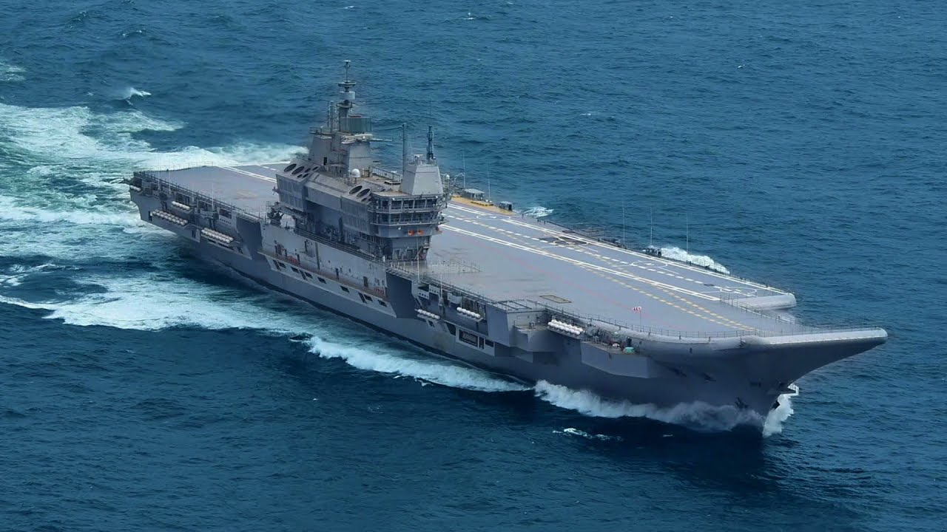INS Vikramaditya
Source : wallpaperaccess.com
The Indian Navy currently lacks a fully-fledged training fleet, with the old INS Tir being the sole dedicated cadet training ship, along with multiple sail training ships. Three modern cadet training ships are currently being built by L&T to fill this capability gap. Four large replenishment vessels are currently in service, with five modern fleet support ships under construction by Hindustan Shipyard Limited and Larsen & Toubro. Such vessels are required to support extended deployments by surface combatants without relying extensively on port calls.
The Indian Navy also has a growing fleet of research vessels. The new Sandhayak class of four survey vessels will soon be followed by five next-generation survey vessels. Together, these are expected to fully replace the older Sandhayak class. The survey vessels will also be complemented by the two diving support vessels of the Nistar class, which also host the Navy’s deep-submergence rescue vessels. With the ever-growing importance of seabed security, more specialised vessels may be required to protect Indian internet data cables and undersea pipelines.
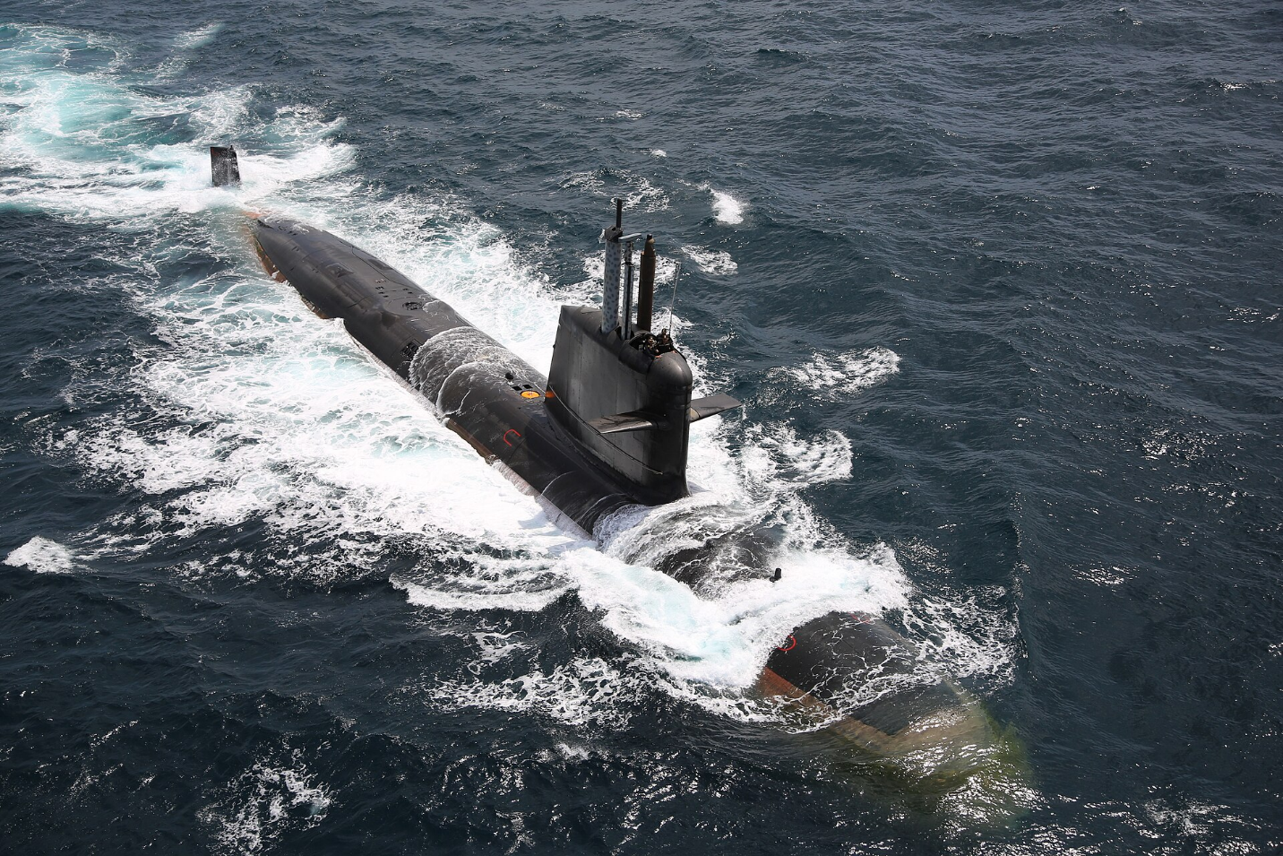INS Kalvari Class Submarine
Source : Wikipdia.org
The Indian Navy also operates several strategic platforms along with other national agencies. INS Dhruv and INS Anvesh are specialised vessels meant for intelligence gathering, tracking, and missile testing purposes. The navy also operates India’s fledgling fleet of Ballistic Missile Submarines (SSBNs).
The Indian Navy’s submarine arm remains the most numerous in the IOR, although the capability and numbers required by the Navy remain unmet. The Diesel Electric Submarines (SSKs) have been actively deployed along the full stretch of the IOR from Oman to Indonesia in recent years. The ageing Kilo class and Shishumar class have been aided by the much-awaited induction of all six Kalvari class SSKs under Project 75. Two nuclear-powered attack submarines have been cleared for construction under Project 77, while an indigenous SSK is being designed under Project 76. Smaller midget submarines are also being designed. Yet India is not self-reliant in making SSKs and is slated to order six under Project 75I, with a possibility of three more Scorpenes or Project 75I SSKs in the future.
Other than the proliferation of the BrahMos among the surface combatants as well as Harpoon and Klub missiles from its submarines, the Indian Navy’s main strike capability comes from its naval air arm. The two aircraft carriers utilise Russian MiG-29K fighters, which are now armed with weapons like the Rampage. 26 Dassault Rafales have been ordered and are expected to complement these fighters, especially onboard INS Vikrant. The Navy operates twelve Poseidon P-8I maritime patrol aircraft, which can be equipped with Harpoon anti-ship missiles. The Navy’s share of 15 MQ-9B High Altitude Long Endurance Unmanned Aerial Vehicles (HALE UAVs), expected to be delivered in a few years, will likely be equipped with indigenous missiles like the Naval Anti-Ship Missile Short-Range (NASM-SR). However, various challenges remain. The Indian Air Force’s (IAF) Sukhoi Su-30 MKI is the only aircraft capable of launching the heavy BrahMos missile from the air. Paired with the range extension of BrahMos, this gives the IAF greater ability to strike targets using aircraft across the IOR than the Navy. IAF also maintains a few Jaguar aircraft in a maritime strike role, equipped with Harpoon missiles. The Navy also lacks the refueling aircraft and Airborne Early Warning and Control System (AWACS) aircraft that the IAF fields. Jointness between the two services will be key and is being helped by a spate of joint exercises in recent years.
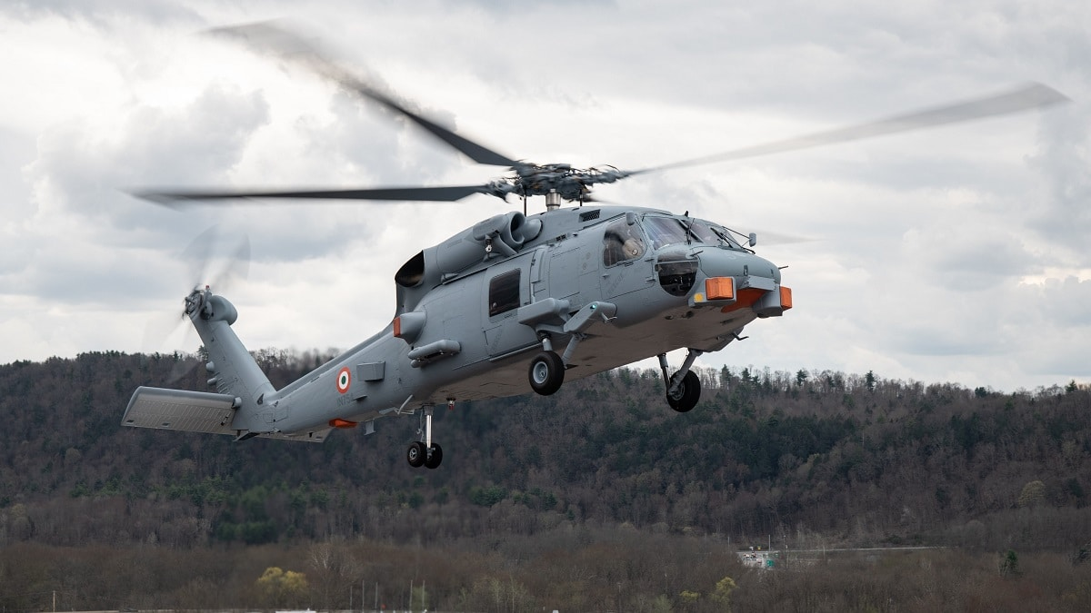
Indian Navy Sikorsky MH-60R Seahawk (Romeo) multi-role maritime helicopter
Source : navalnews.com
In the realm of naval helicopters, slow but steady advances are being made. The induction of the MH-60R has helped bolster Anti-Submarine Warfare (ASW) capability onboard the carriers and surface combatants. The Advanced Light Helicopter - Maritime Role (ALH MR) fleet has a turbulent record but remains vital for operations. Acquisition programs are yet to fructify, with the Naval Utility Helicopters (NUH) and Naval Multi-Role Helicopters (NMRH) programs failing to deliver. Efforts continue to acquire such helicopters even as Hindustan Aeronautics Limited (HAL) develops the Utility Helicopter - Maritime (UHM) and designs the Indian Multi-Role Helicopter (IMRH) and Deck-Based Multi-Role Helicopter (DBMRH) to fulfil both needs.

Amidst global tensions and delayed procurement and delivery of equipment, self-reliance is a key objective. With an eye on global advancements, the Navy is looking to accelerate the induction of uncrewed systems, including Unmanned Surface Vehicles (USVs), Unmanned Undersea Vehicles (UUVs), and loyal wingmen aircraft (UAVs). Efforts to indigenise the supply chain have also been taken, with indigenous development of engines and batteries a key priority. Unique projects like the Defence Research and Development Organisation’s Supersonic Missile-Assisted Release of Torpedo (SMART) and hypersonic weapons can help the Indian Navy maintain its offensive edge in the IOR, while directed energy weapons and railguns can bolster the defences of ships and shore establishments. Structural reforms like the Maritime Theatre Command will bring cohesiveness and jointness to tackle maritime threats effectively.
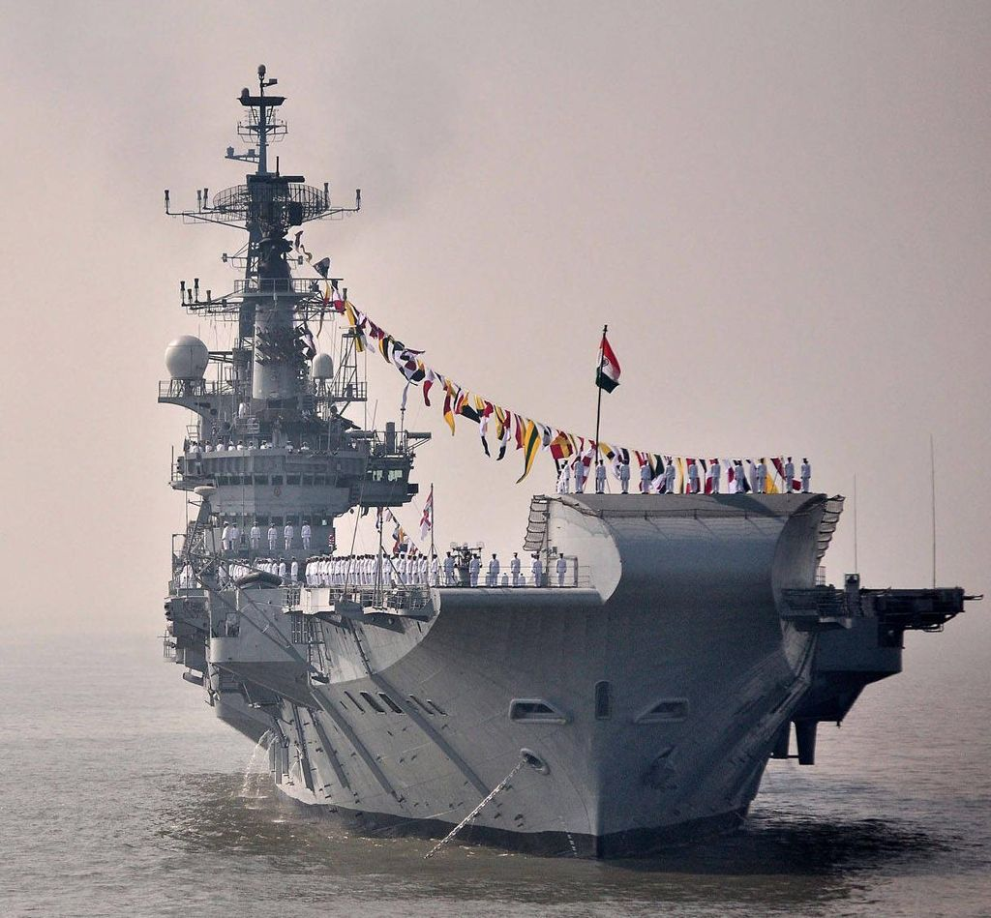
INS Vikramaditya
Source : wallpaperaccess.com
Maritime diplomacy efforts remain strong with India extending support to its IOR neighbours in various forms, such as the Information Fusion Centre - Indian Ocean Region (IFC-IOR), Security and Growth for All in the Region (SAGAR), Mutual and Holistic Advancement for Security and Growth Across Regions (MAHASAGAR), and other initiatives. Diplomatic support to Mauritius over the Chagos Islands, as well as in the development of Agalega Island, shows the importance of a whole-of-nation approach to support and defend maritime interests. Maldives, Seychelles, and Mozambique regularly receive Indian equipment and training, while countries like Sri Lanka, Oman, and Indonesia often host Indian vessels visiting the region. Robust diplomacy helps maintain peace and safeguard India’s maritime interests.

